BLOOM’S REVISED TAXONOMY


Creating
Generating new ideas, products, or ways of viewing things
Designing, constructing, planning, producing, inventing.



Evaluating
Justifying a decision or course of action

Checking, hypothesising, critiquing, experimenting, judging


Analysing
Breaking information into parts to explore understandings and relationships

Comparing, organising, deconstructing, interrogating, finding

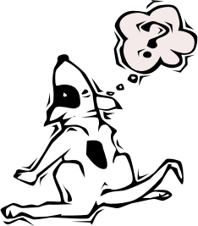

Applying
Using information in another familiar situation

Implementing, carrying out, using, executing


Understanding
Explaining ideas or concepts
Interpreting, summarising, paraphrasing, classifying, explaining



Remembering
Recalling information

Recognising, listing, describing, retrieving, naming, finding

